Ann Proctor

**Vietnamese Artists in Paris**

Vietnam was a French colony when Paris’ influence as the centre of the art world was at its peak. Despite this, few Vietnamese ventured to France in order to establish or further their artistic education. Reasons for this apparent anomaly include the fact that prior to the middle of the 20th century few Vietnamese even left the place where they were born. In addition, French colonial rule restricted overseas travel for their subjects. The very few artists who went to France were from well-to-do backgrounds and generally travelled either under a scholarship or in association with international exhibitions, such as the Colonial Exhibition that took place in Paris in 1931 or the World’s Fair of 1937. Artists who moved overseas for political reasons generally never returned to Vietnam, but for the men and women who did return in the first half of the 20th century, they aided a radical transformation in the Vietnamese experience of painting and sculptural practice, moving the arts into a modern international framework. Changes occurred in the aesthetic and physical appearance of art works, as well as in the way arts education was received, the manner in which art works circulated and ultimately in the societal role of the artist, as prior to colonization by France, Vietnamese art was generally produced within specific guilds.

During their time in France, Vietnamese artists not only absorbed the influences of Western modernism from their French professors and the exhibitions and museums they visited, but they also associated with other foreign artists. In particular they made contact with artists from Asian nations who faced similar dilemmas in negotiating a move into the modern era without losing their national voice: an aspect of particular importance during a time of rising nationalism in Asia generally and the independence movement in Vietnam in particular.

The earliest known Vietnamese artist to study in Paris was Lê Văn Miến(1873-1943). Hecame from an influential family and was selected by the Vietnamese court in Huế to study in France. Choosing to pursue art rather than develop his administrative skills, he attended the École de Beaux-Arts in Paris from1891 to 1894, where he studied under the academic realist J.L. Gerome (1824-1904) and became a proficient oil painter. Painting with oil on canvas was an unfamiliar medium for pre-modern Vietnamese artists, who generally used ink on silk or paper, mural painting or painting on ceramics. Furthermore, realism was an unfamiliar concept in an environment where artistic works were generally produced for festive, ceremonial or religious purposes and the primary consideration in creating such works was the meaning or spirit conveyed in the work rather than verisimilitude. On his return home Lê Văn Miến worked as an illustrator for the Schneider press and taught at a Franco-Vietnamese school in Huế.

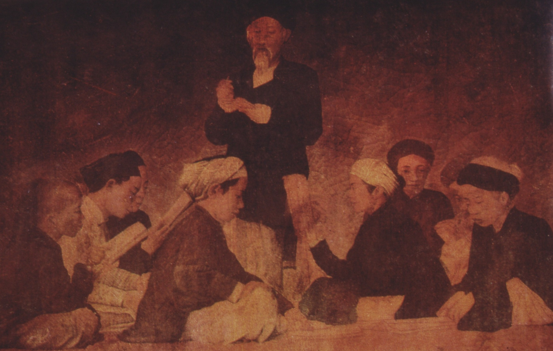

Lê Văn Miến, *Literary Discussion*, 1905, oil on canvas, 68 x 97 cm, Fine Arts Museum of Hanoi.

The first Vietnamese director of an art school in Vietnam was Huynh Dinh Tuu, director of the Gia Dinh School in Saigon between 1922 and 1925. He studied in France with Louis Bate who subsequently won the Prix de l’Indochine in 1938. The prize was awarded by the French Government between 1910 and 1938 for French painters to travel and teach in Indochina and the recipients were generally academic, conservative, painters.

Nam Sơn (Nguyễn Văn Thọ) (1890-1973) was another early Vietnamese painter who studied in France. From a Hanoian family of scholars, he obtained a classical education prior to pursuing his interest in art, studying privately under French teachers. Nam Sơn was introduced to Victor Tardieu (1870-1937) who was in Hanoi as a recipient of the 1920 Prix de l’Indochine. The two travelled to Paris in order to recruit staff and obtain supplies for the proposed art school in Hanoi, which was officially approved in 1924. In Paris, Nam Sơn studied at the École des Beaux Arts (1925-1927) with Jean-Pierre Laurens and at the École Nationale des Arts Decoratifs with Félix Aubert. Although his style was greatly influenced by his French professors, Nam Sơn nevertheless maintained that it was important to learn from both Western and Asian art history. Such a view is evident in his 1931 book on Chinese painting in which he praised the use of line and harmony in Chinese works, while noting that the lack of figural studies, a feature of realism, as a shortcoming.

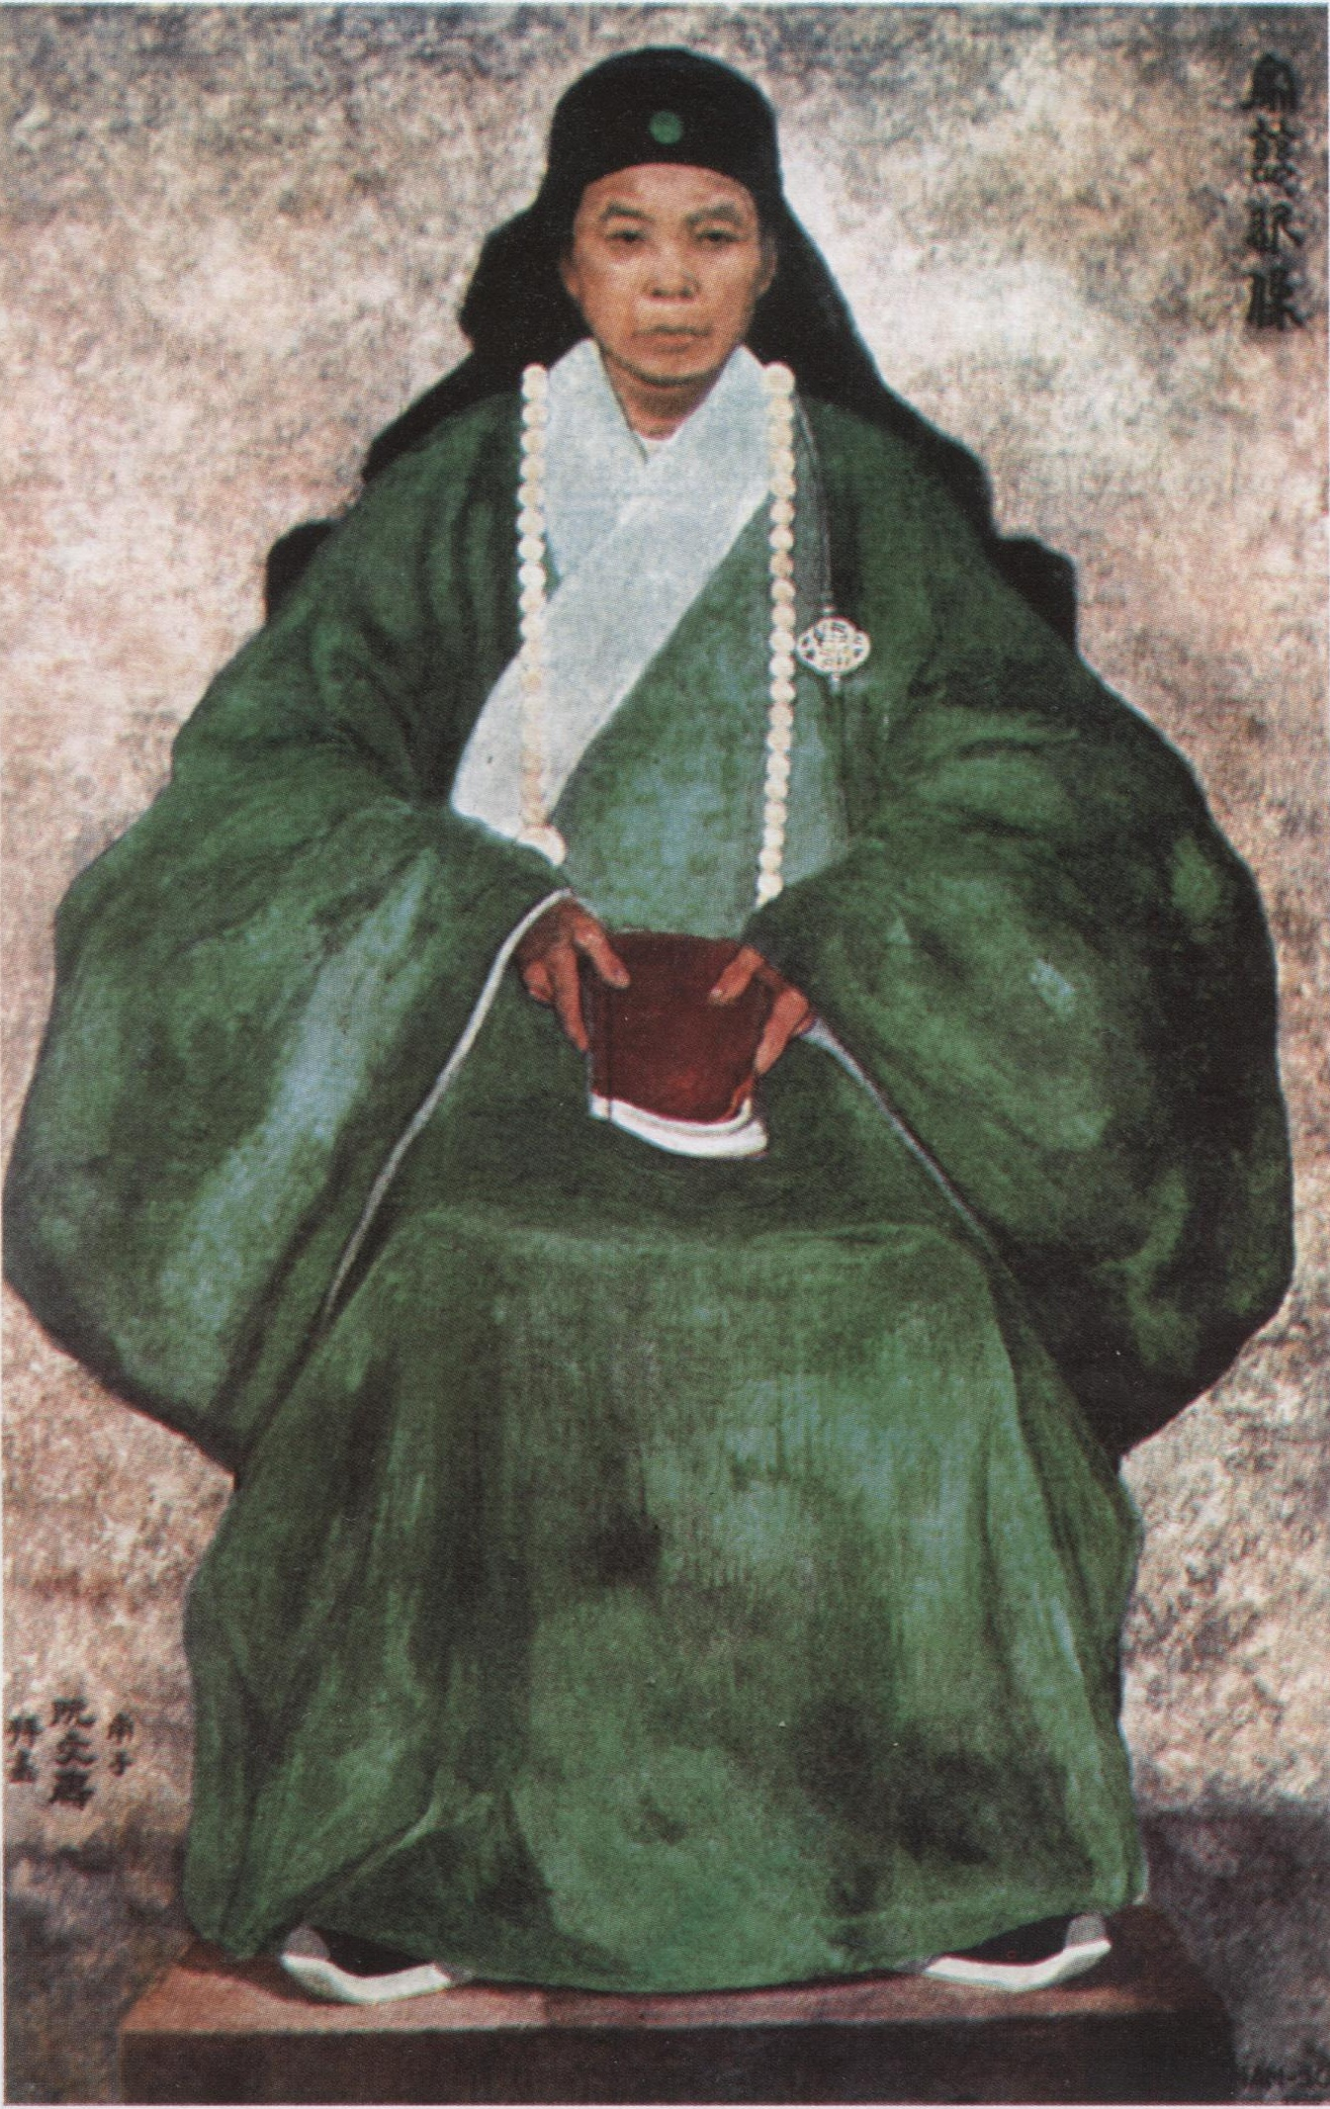

Nam Sơn, *Portrait of Mother*, 1930, oil on canvas, winner of silver medal at the 1932 French Salon exhibition, unknown collection.

In Paris Nam Sơn also met with other foreign students such as Japanese artist Tsuguharu Foujita (1896-1968). These two exchanged visits to each other’s countries in 1941and 1943, for reciprocal exhibitions during the Japanese occupation of Vietnam. The Chinese modernist, Xu Beihong (1895-1953) was another colleague. Both returned to their home countries in 1925 and remained in contact with each other until Xu Beihong’s death.

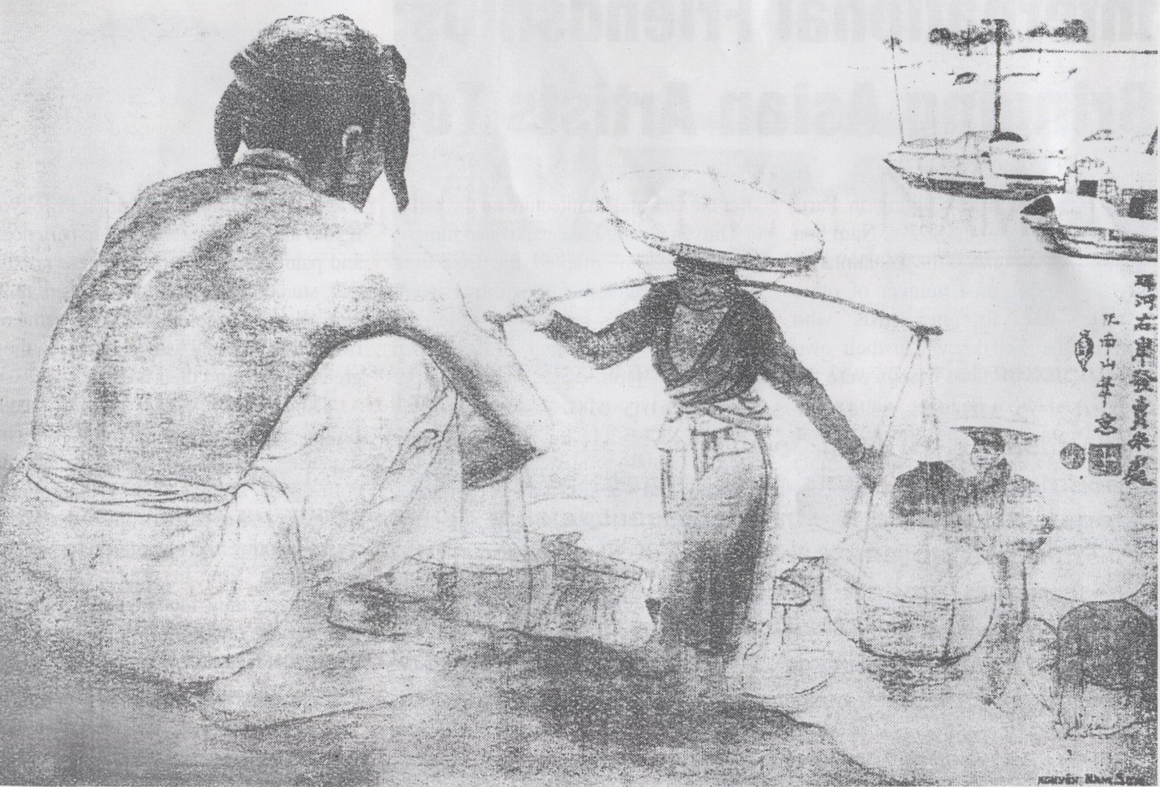

Nam Sơn, *Riche Market by the Red River*, 1930, India ink on paper, Louvre, Paris.

Lê Thị Lựu, (1911-1988) who studied and subsequently taught at the École des Beaux-arts de l’Indochine (EDBI), Hanoi, became the first Vietnamese woman to become a professional painter. She later travelled to France with her husband, having previously won an award in the 1931 Paris Exposition.

Between 1925 and 1945 works by promising students and staff from the EDBI, travelled to France for exhibitions. The style of these works exhibited reflected an Orientalist taste for exotic tropical scenery, beautiful women and picturesque agricultural activities executed in an academic manner rather than reflecting innovations circulating amongst the avant-garde of Europe at the time. Vietnamese artists who travelled to Paris for the Colonial Exhibition of 1931 and the World Fair of 1937 included Lê Phở (1907-2001) Mai Trung Thứ(1906-1980) and Vũ Cao Đàm (1908-2000), all of whom came from well to do backgrounds and who eventually remained in France or Europe for the remainder of their successful art careers.

Đìem Phùng Thị (1920-2002), a sculptor, and Lê Bá Ðẚng(b.1921-), an abstract painter, both went to France in their youth, Diem initially working as a dentist prior to establishing herself as a modernist sculptor. Both returned to Vietnam late in life to established private museums of their work in Huế.

**References and further reading**

de Ménonville, Corinne, (2003) *Vietnamese Painting: From Tradition to Modernity*, Paris: Les Editions d’Art et d’Histoire.

Lee, S. and Nguyen Nhu Huy, eds., (2009) *Essays on Modern and Contemporary Vietnamese Art* , Singapore Art Museum

Nam Sơn. (2003) ‘Outline for a Vietnamese Art School’, *Vietnam Cultural Window*, no. 59, p.6

Nam Sơn. (2003) ‘La peinture chinoise: Technique et Symbolisme- Manière spéciale des Chinois d’interpréter la nature,’ *Vietnamese Studies*, no. 3, 149, p79-101

Musée Cernuschi, (2012) *Du Fleuve Rouge au Mekong: Visions du Viêt Nam*, (exhibition catalogue). Paris: Musée Cernuschi.

Noppe, Catherine &Hubert, Jean- François. (2003) *Art of Vietnam*, New York: Parkstone Press.

Nguyễn-Long, Kerry. (2013)*Arts of Việt Nam 1009-1945,* Hà Nội: Thế Giới Publishers

Masahiro Ushiroshoji & Toshiko Rawanchaikul. (1997) *The Birth of Modern Art in Southeast Asia*: *Artists and Movements,* Fukuoka: Fukuoka Art Museum.